Title Here
[NAME]
BUSH FIRE MANAGEMENT COMMITTEE

AGENDA
Meeting:
Convened by:
Location:
Date: Time: Minutes by:

Table 1: Agenda Items
Agenda heading 1 | Responsible

Agenda heading 2 | Responsible

Agenda heading 3 | Responsible

Agenda heading 4 | Responsible

Agenda heading 5 | Responsible

Agenda heading 6 | Responsible

Agenda heading 7 | Responsible

Agenda heading 8 | Responsible

Next Meeting Date:

Table 2: Open Action Items from the Last Meeting
Reference No.
Item Description: | Due date:
Status: | Responsible:

Reference No.
Item Description: | Due date:
Status: | Responsible:

Reference No.
Item Description: | Due date:
Status: | Responsible:

Reference No.
Item Description: | Due date:
Status: | Responsible:

Reference No.
Item Description: | Due date:
Status: | Responsible:

Table 3: Documents to be tabled
Document title | Author | Date

Table 4: Correspondence Register
[Title Here]
BUSH FIRE MANAGEMENT COMMITTEE CORRESPONDENCE
[Date] to [Date]

Correspondence in Correspondence out
No. | From | Date Receive | Subject | Document Reference |  | No. | Subject | Date Receive | Addressed To | Document Reference
1 |  |  |  |  |  | 1
2 |  |  |  |  |  | 2
3 |  |  |  |  |  | 3
4 |  |  |  |  |  | 4
5 |  |  |  |  |  | 5
6 |  |  |  |  |  | 6
7 |  |  |  |  |  | 7
8 |  |  |  |  |  | 8
9 |  |  |  |  |  | 9
10 |  |  |  |  |  | 10

Business Paper Template

[Name]
BUSH FIRE MANAGEMENT COMMITTEE

AGENDA
Title of the Report:
Purpose:
Recommendation:
Purpose: To Note / Action / Assign / Endorse

Recommendation: Type here
Background: Type here
Current Position: Attachments (s):
Name: Type here
Title: Type here
Contact number: Type here

Organisation Report Template

[Name]
BUSH FIRE MANAGEMENT COMMITTEE

AGENDA Item:
Date:
[Name of Organisation] Progress Report

Item | Progress Summary
Action Items
Provide an overview of the status of any BFMC Action Items assigned to your organisation
Bush Fire Risk Management Plan
Provide an outline of any treatment activities completed since the last BFMC meeting. Overview of any planned activities coming up.
Fire Access and Fire Trail Plan
Summarise any fire trail works that have been completed since the last BFMC meeting. Planned activities.
Operations Coordination Plan
Provide an update of any significant operational / response and pre-incident planning activities that have occurred since the last BFMC meeting.
Advise of any significant changes in personnel and contacts as listed in the OCP appendices.
Training / Joint Initiatives
Include information on any past or upcoming training / joint initiatives that are relevant to the BFMC
Infrastructure
Provide an overview of any changes / enhancements to infrastructure that would be of interest to the BFMC
General
Summarise any other matters that would relate to BFMC business (e.g. tenure changes, new relevant organisation policy or plans)

Minutes Template
[Name]
BUSH FIRE MANAGEMENT COMMITTEE MINUTES

Meeting: Meeting number/year
Convened by: [Chairs name – Organisation]
Location: [Place, address, room]
Date and time: [day, date, time]
Minutes by: [name – organization]

Table 1: Attendance Record

Members (alternate) | Organisation | Present | Apology | Absent

Observers / Support | Organisation | Present | Apology | Absent
Table 2: Documents Referred to in the Meeting

Document title | Author | Date

Minutes
Item 1 | Welcome/Acknowledgement to Country | Chair

Item 2 | Apologies | Chair
As outlined above
Item 3 | Disclosure of Interests | Chair

Item 4 | Confirmation of Minutes of #/YEAR [insert # of last meeting /year] meeting held [date previous meeting] | Chair

Item 5 | Business arising from previous minutes - Action Items | Chair

Table 3. Outstanding Action Items From [Date] Meeting

Ref No. | Item Description | Responsible | Due Date | Status

Updates have been provided on the following items.

01/18-3 Action Name
Provide update
01/19-1 Action Name
Provide update

Item 6 | Correspondence Register | Chair

Item 7A | Report from Subcommittees [name] Subcommittee

Item 8A | Progress on BFRMP strategies/tasks [report from each organisation in turn – every meeting]

Item 8B | Annual Works Plan

Item 8C | Monthly HR Reports from BRIMS

Item 9 | Report on Operations Coordination Plan [report from each organisation in turn – every meeting]

Item 10 | Fire Access & Fire Trail Register

Item 11 | Grant Funding

Item 12 | Seasonal Outlook

Item 13 | General Business

Item 14 | Close

Table 4. Updated Action Items

Ref No. | Item Description | Responsible | Due Date | Status

Table 5. Next meeting

Date | Start time | Finish time | Location
 | 00.00am | 0.00pm

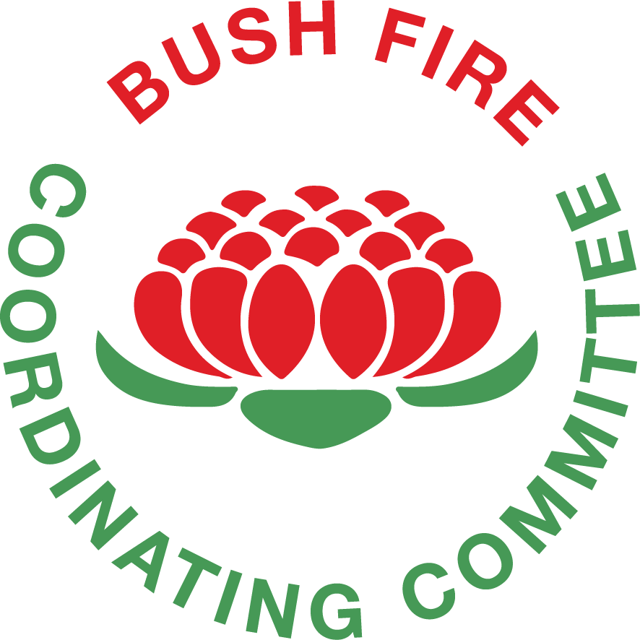
[Name]
BUSH FIRE MANAGEMENT COMMITTEE
Address all correspondence to: Executive Officer Address here

Type organisation
Type address
Phone number
Email address

Dear

Your sincerely,

Invitation for BFMC Membership Letter (Sample)
BUSH FIRE MANAGEMENT COMMITTEE
Address all correspondence to: Executive Officer Address here

Type organisation
Type address
Phone number
Email address

Dear
RE: Invitation for membership of [Name] Bush Fire Management Committee
I am writing to invite you to nominate a representative from your organisation for the [Name] Bush Fire Management Committee (BFMC).
BFMCs are groups of people with technical expertise, experience and local knowledge who work together for bush fire management purposes, and who can collaboratively develop better bush fire management decisions than anyone acting alone.
The BFMC is responsible for preparing, reviewing and updating a Bush Fire Risk Management Plan, the Operations Coordination Plan and Fire Access and Fire Trail Plan, within the local area.
The Rural Fires Regulation 2013 states that a person nominated by [insert relevant section of the regulations Section 14 for the organisation you are writing to] located in the Bush Fire Management Committee’s area, is eligible to join the BFMC.
Your organisation is not, at present, represented on the [Name] BFMC and as such I would like to invite and encourage you to nominate a representative to join the committee.
The next general meeting will be held on [Date] at [Place] at [Address]. If your organisation would like to have representation on the [Name] BFMC, it would be appreciated if you could notify the Executive Officer prior to the above date so that appropriate correspondence and notification of events can be sent accordingly.
Your assistance in this matter would be greatly appreciated
If you have any enquiries or would like further information about the BFMC and its operations, please do not hesitate to contact me.
I look forward to hearing from you.

[Name]
Executive Officer/Chair
[Name] Bush Fire Management Committee

BFMC Welcome Letter (Sample)
BUSH FIRE MANAGEMENT COMMITTEE
Address all correspondence to: Executive Officer Address here

Type organisation
Type address
Phone number
Email address

Dear
Re: Welcome to the [Name] Bush Fire Management Committee
May I take this opportunity to welcome you to the [Name] Bush Fire Management Committee (BFMC), as the member representing the [Organisation].
As with the previous ([Organisation]) representatives I am certain we will continue the productive and collaborative relationship that has existed in the past and thank you for your willingness to be involved. We welcome the participation of {Organisation} on the BFMC and are looking forward to your contribution to the work of the BFMC.
The Committee meets [insert number] times a year and you will receive confirmation of the meeting date, time and location, together with a copy of the agenda, prior to the meeting.
The remaining scheduled BFMC meetings for this year are [dates]. Please find the minutes of the last BFMC meeting, which has been enclosed to this correspondence to provide some background.
Also enclosed is a copy of the BFMC Charter, which will provide an introduction to the BFMC and your role as a member of the Committee.
I would also like to direct you to the BFMC Handbook. This document contains additional information that will further assist you in understanding your role and expands on the information that is provided in the BFMC Charter. The BFMC Handbook is downloadable on the NSW RFS website https://www.rfs.nsw.gov.au/__data/assets/pdf_file/0003/9624/BFMC-Handbook-Edition-1-June-2006.pdf.
Please do not hesitate to contact me should you wish to be personally briefed on the role of the Committee, its Bush Fire Risk Management Plan, Operations Coordination Plan, Fire Access and Fire Trail Plan, and the matters currently being dealt with.

Yours sincerely,

[Name]
Executive Officer/Chair
[Name] Bush Fire Management Committee

Standard Email Text – Call for Agenda Items

Note: Call for agenda items should be sent at least of 1 month prior to the meeting of the BFMC.

Dear xxx BFMC members and delegates
Please advise if you have any agenda items you would like added to the agenda for the upcoming xxx BFMC meeting to be held at [time, date, location]. Suggestions for items will need to be received by [date] in order to be included in the agenda.
Can you please confirm your availability for this meeting and advise if you seek to have any observers or guests attend.

Thank you
[Name]
Executive Officer
[Name] Bush Fire Management Committee

Standard Email Text – Distribution of Agendas and Business Papers.

Note: Agendas and business papers should be sent a minimum of 7 days prior to the meeting of the BFMC.

Dear xxx BFMC members and delegates,
Attached is the agenda, business papers and related documentation for the next xxx BFMC meeting to be held at [time, date, location]. Please review this documentation as well as any action items assigned to your organisation and ensure you are in a position to discuss these matters at the meeting.
Draft minutes of the previous meeting [and any other supporting material] are also attached for your review and comment.
If you haven’t already, it would be appreciated if you could confirm your availability for this meeting along with the attendance of any observers or guests by close of business today.

Thank you
[Name]
Executive Officer
[Name] Bush Fire Management Committee

BFMC Calendar (Sample)

(Insert Name XXX) BUSH FIRE MANAGEMENT COMMITTEE
Establishment date of BFMC: (insert date XXX)
BFMC SCHEDULE
WHEN | WHAT | WHO | DATE
MONTHLY
5 business days after the end of each month | Data must be entered in BRIMS/GUARDIAN for completed activities | Agencies
YEARLY
Start or end of the year | Prepare 12 months calendar of BFMC meeting dates | BFMC (Executive Officer)
August 31 | Pre-season Checklist Due for Submission to BFCC | BFMC
Near the establishment date of the Committee | Elect Chairperson and deputy Chairperson | BFMC
Near the establishment date of the Committee | Contact those organisations eligible for BFMC membership and issue an invitation to provide a member to the BFMC. This should be done in writing. | BFMC (Chairperson / Executive Officer)
EVERY 2 YEARS
The dates for submission are based on the establishment date of your BFMC | Prepare and submit S52 Operations Coordination Plan | BFMC
EVERY 5 YEARS
Submission dates are based on the establishment of your BFMC | Prepare and submit S52 Bush Fire Risk Management Plan | BFMC
 | Prepare and submit S52 Fire Access and Fire Trail Plan | BFMC
ANNUAL SCHEDULE
January 10 | Quarterly Reports Due/Prepared | AGENCIES
March | Consider Variation to Extend the Bush Fire Danger Period | BFMC
 | BFMC Meeting
April 10 | Quarterly Reports Due/Prepared | AGENCIES
May 31 | Annual Works Plan Due for Submission to BFCC | BFMC
 | BFMC Meeting
July 10 | Quarterly Reports Due/Prepared | AGENCIES
August 1 | Annual Report and Progress Report on the Implementation of BFRMP Treatments Due for Submission to BFCC | BFMC
August 31 | Pre-season Checklist Due for Submission to BFCC | BFMC
 | BFMC Meeting
July / August / September | Consider Variation to Bring Forward the Bush Fire Danger Period | BFMC
October 10 | Quarterly Reports Due/Prepared | AGENCIES

Organisation  Responsibilities | BFMC Responsibilities  as listed in BFCC Policy | BFMC Meeting  (to be input based on BFMC agreed dates)

Bush Fire Management Committee Members Role and Checklist
Bush Fire Management Committee Members Role Description
The ultimate role of a member is to contribute to the functioning of a Bush Fire Management Committee (BFMC) and the achievement of its mission statement outlined in the BFMC Charter. Members are to contribute their specific expertise and commit their organisation to actions that results in the delivery of the best possible bush fire protection outcomes for the community.
The core responsibilities of a member is to:
- Represent their organisation’s interests on the BFMC and participate in discussion and decision-making.
- Provide advice, information and reports.
- Report back to their organisation
- Contribute to the work of the BFMC
- Attend meetings
- Prepare for meetings
- Contribute to development of plans and other tasks as required
More detail on the responsibilities of a member is outlined in Section 5.4 of the BFMC Handbook.

Members Checklist
Things to do at the Start of the Year
 | Action | When | Completed?
1
2
3

Things to do Prior to a Meeting
 | Action | When | Completed?
1
2
3

Things to do During a Meeting
 | Action | When | Completed?
1
2
3

Things to do After a Meeting
 | Action | When | Completed?
1
2
3

Bush Fire Management Committee Chairperson Role and Checklist
Bush Fire Management Committee Chairperson Role Description
The Chairperson is a key leadership role for the BFMC. They are responsible for running each meeting as well as signing plans and official correspondence from the BFMC to the Bush Fire Coordinating Committee. Other core responsibilities of the Chairperson to:
- Ensure the BFMC carries out its statutory obligations.
- Determine the agenda for each BFMC meeting.
- Ensure BFMC meetings are held in a timely manner and that required documents and reports are submitted by the due dates.
- Provide leadership to the BFMC in its deliberations and facilitate consensus outcomes.
- Establish and foster a cooperative working relationship within the Committee.
- Approve the attendance of guests and observers at each BFMC meeting.
- Ensure meetings are effective and everyone is given an equal opportunity to participate in the deliberations of the BFMC.
More detail on the Chairperson role is outlined in Section 6 of the BFMC Handbook.
Determining Consensus
Perhaps one of the most important function performed by the Chairperson is the facilitation of consensus decision-making and resolution or avoidance of conflict amongst the BFMC members. Guidance and techniques for determining consensus and resolving conflicts are contained within BFCC Policy 1/2000 – Dispute Avoidance – Dispute Resolution. With regard to consensus decision-making, some of the main points for a Chairperson to note from this policy are:
- Once the Chairperson believes that consensus has been reached, confirm the official position with the BFMC members. This can be done by asking the following questions:
  - Have we consensus to support the proposal?
  - Have we consensus not to support the proposal?
Where consensus has been achieved, the Chairperson should declare the proposal approved or not and the outcome must be included in the meeting minutes. Where consensus hasn’t been achieved the discussion should be allowed to continue.

- In the event that there is strong, but not unanimous, support for the proposal the Chairperson may put to the Committee further questions to assess the level of support, such as:
  - Who supports the proposal?
  - Who does not support the proposal but is prepared to accept it?
  - Who is not prepared to accept the proposal?
The Chairperson may announce that the issue has been resolved by consensus provided there is no response to the last question.
- Should members of the Committee not be prepared to accept the proposal, the Chairperson should facilitate further discussion and clarify the key points affecting consensus decision-making. The Chairperson or other members of the BFMC can then suggest options that allow for the resolution of the issue. Minor objections may sometimes be overcome by rewording of the proposal.
- After all attempts to reach consensus are unsuccessful and there is still a minority of Committee members who are unable to support a consensus position, the Chairperson may ask the following questions:
  - Do those who are unable to support the proposal and are not prepared to accept it agree that your point of view has been listened to, even though you do not agree with the proposal, and are not prepared to accept it?
  - Do those who support, or are prepared to accept the proposal agree that you have been listened to and have heard what others on the Committee have been saying?
The points of differed should be clearly highlighted and documented in the meeting minutes. Resolution may be sought by seeking guidance from external persons such as subject matter experts or relevant staff from the NSW Rural Fire Service Headquarters. In some cases, it may be appropriate to refer the matter to the BFCC for advice and possible determination.

Chairperson Checklist
Things to do at the Start of the Year
 | Action | When | Completed?
1
2
3

Things to do Prior to a Meeting
 | Action | When | Completed?
1
2
3

Things to do During a Meeting
 | Action | When | Completed?
1
2
3

Things to do After a Meeting
 | Action | When | Completed?
1
2
3

Bush Fire Management Committee Executive Officer Role and Checklist
Bush Fire Management Committee Executive Officer Role Description
The Executive Officer (XO) is responsible for arranging clerical and logistical support to ensure that the Bush Fire Management Committee (BFMC) functions efficiently and effectively. The position essentially operates as the Secretary for the Committee.
The core responsibilities of the XO is to:
- Prepare agendas, minutes and BFMC correspondence.
- Compile reports and business papers.
- Book, prepare and arrange meetings.
- Collate apologies.
- Maintain, manage and hold BFMC files and records.
- Maintain membership records and contact details.
- Distribute BFMC correspondence.
- Distribute copies of correspondence from the BFCC as soon as it is received.
- Maintain the correspondence register
- Provide induction material.
- Distribute any other relevant information to BFMC members in a timely manner.
- Assist the BFMC Chairperson and members
The XO does not “own” or “run” the BFMC. Any actions not prescribed in the BFCC Policy including the BFMC Charter and Handbook, needs prior consent from the BFMC. As per Clause 18 of the Rural Fires Regulation 2013, the XO is also a member of the BFMC. It is important that the XO clearly differentiates between the two roles when engaging in BFMC business and decision-making.
More detail on the XO role is outlined in Section 7 of the BFMC Handbook.

Executive Officer Checklist
Things to do at the Start of the Year
 | Action | When | Completed?
1
2
3

Things to do Prior to a Meeting
 | Action | When | Completed?
1
2
3

Things to do During a Meeting
 | Action | When | Completed?
1
2
3

Things to do After a Meeting
 | Action | When | Completed?
1
2
3

